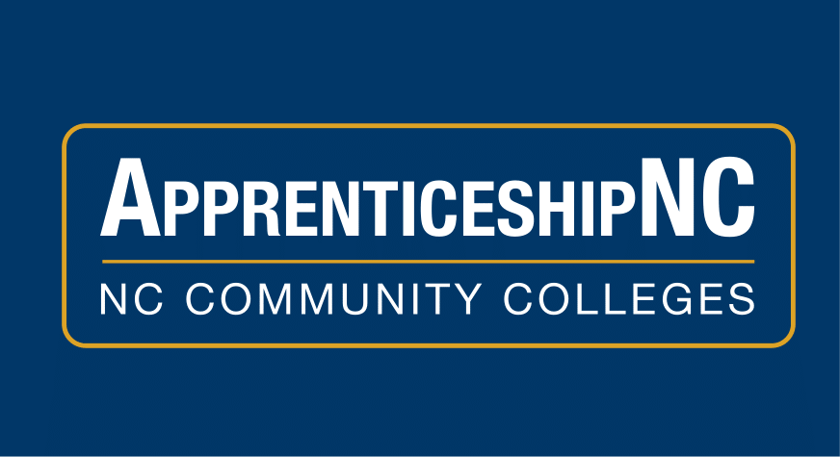

Apprenticeship Week Proclaimed for the State of North Carolina
Recognizing Apprenticeship’s Impact on Workforce Development
Raleigh, North Carolina Nov 7, 2023 —Governor Roy Cooper proclaimed November 13-19, 2023, Apprenticeship Week in the State of North Carolina. This proclamation recognizes the ways registered apprenticeship furthers North Carolina’s economic and workforce development. Apprenticeship is a time-tested solution for businesses to build and retain a skilled workforce. The U.S. Department of Labor’s celebration of National Apprenticeship Week will occur concurrently on the dates proclaimed in Cooper’s proclamation.
National Apprenticeship Week is a nationwide celebration where employers, industry associations, labor organizations, community-based organizations, workforce partners, education providers, and government leaders host events to showcase the successes and value of Registered Apprenticeship (National Apprenticeship Week | Apprenticeship.gov). ApprenticeshipNC sponsors/employers from across the state will host events celebrating registered apprenticeship for youth, new and emerging industries, underserved populations, and veterans and federal employees.
ApprenticeshipNC is the State Apprenticeship Agency operating under the NC Community College System. ANC’s mission is to build an adaptable, skilled, and efficient workforce through the registration of apprenticeship programs across North Carolina. ANC connects employers and apprentices to U.S. Department of Labor registered apprenticeship occupations as well as to federal and state funding. Apprentices, who are paid during their apprenticeship, receive on-the-job training and formalized classroom instruction. They also earn certifications, industry specific credentials, and, depending on their program, college degrees.
“ApprenticeshipNC works with employers across the state, in all 100 counties, to develop registered apprenticeship programs. Apprenticeships are employer led and solidify the importance of developing a strong, skilled, prepared workforce, allowing North Carolina to attract business and industry as well as people to our state.” – John Loyack, Vice President of Economic Development North Carolina Community College System
For more information:
www.apprenticeshipnc.com

For more information, press only:
Amy Davis-Moore  Davis-moorea@nccommunitycolleges.edu  919-618-6249 | Margaret Spainhour  Spainhourm_tmp@nccommunitycolleges.edu  919-618-6249

